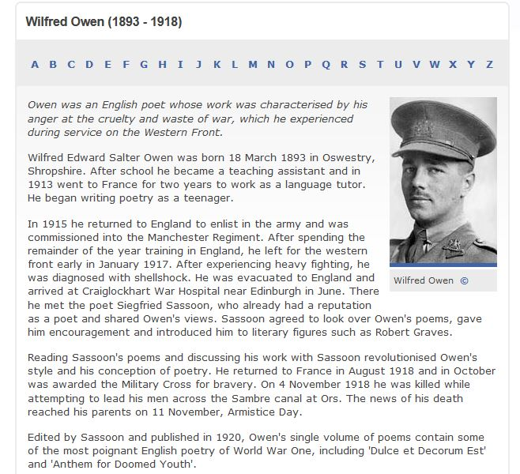

“Wilfred Owen.” History-Historic Figures. BBC. Archived. Accessed 5 June 2017. http://www.bbc.co.uk/
history/historic_figures/owen_wilfred.shtml

