20 June 2012
I think that content area teachers (including those of us teaching writing and literature) often overlook the importance of using art analysis in our classrooms to supplement written texts. Some students simply do not think in text. In our visual society, kids need something they can see. Allowing them to look at, examine, analyze, and discuss related art helps them begin to form concrete connections between content and real-life.
This year, for the first time, I used a form of art analysis in my classroom. In our brick red Glencoe Course 5 Literature books, the editors included paintings, photographs, and etchings which support various texts and passages. As we read through Shakespeare’s Julius Caesar, the staple Elizabethan tragedy for tenth graders, some students struggled with drawing connections between characters and action and theme. In the sidebar of the play’s text, in the same place it had been each of the four years I had taught this play, was the print of a dark, shadowy painting: Sir Edward John Poynter’s “The Ides of March.”
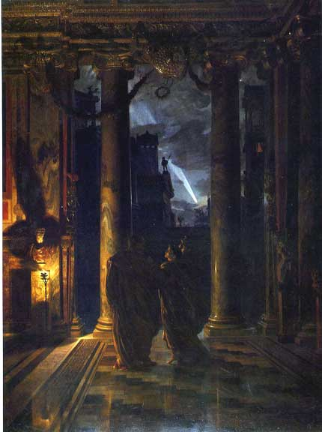
On one of those sudden “teachable moments” whims, I asked all of my students to look at the painting silently and to make a list of what they saw. Then, with a partner, they explained how the images from the painting connected with Shakespeare’s play, and wrote those connections to the side of the images they listed. Finally, I pulled the painting up from a website and projected it on the Smart Board, and students guided me through the painting—the images they saw, the significance of color usage, the importance of the background, foreground, etc. Students who, a few minutes before, could not seem to outline the plot of the play began to verbalize the connections they were seeing and even to argue with classmates about the meaning of images and colors in the painting.
This activity made something click with me: students need visual representations to help them draw authentic connections between texts and real-life.

